**ETHERIA**

Etheria is a board game that can be played for 2-6 players.

The goal is to reach the end of the path which is full of obstacles and evils, and try survive while doing so.

Etheria is about finishing the path first.

So basically first one to finish the path wins the game.

**How To Play?**

**Basic turn mechanics:**

1. Pick the piece that you want to play throughout the game.
2. Every player starts the game with 10 Health.
3. Roll a six faced dice. Go forward for the number that comes up.
4. If you come to an unit that has good or bad effect. Draw the according card. You are effected from what the card says. Put the card at the bottom of the deck.
5. Pass the turn to other players. (Turn goes clockwise).

**6**. When the turn comes to you again, repeat from the 3rd step

**TERMINOLOGY**

**Portals**: When you come to a portal, you will teleport to the other one. If you come to the first one, you will teleport to latter one. If you come to the latter one, you will teleport to first one.

**Shortcut:** If the player chooses. He/She can use the shortcut. But remember you are not in the path anymore, which is safe. So surely there will be monsters that want to attack you. So, you can choose to use the shortcut with the cost of indicated damage. Do it at your own risk!

**Respawn**: If you have respawn card at hand. You can return to game from the respawn point when you die.

**CARDS**

**Good Cards**: Good cards have good effect on them.

**Bad Cards:** Bad cards have bad effect on them. Chance Cards: This rare cards have powerful effects on them.

**Chance Cards:** This rare cards have powerful effects on them.





**STORY**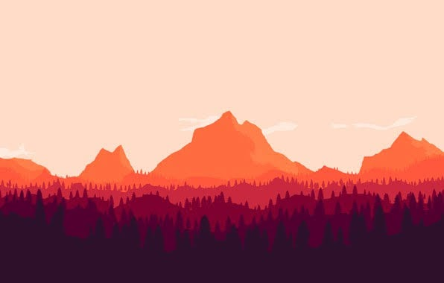

According to thousands of years old prophecy, the one that reaches the summit of the misty and might mountain Etheria is rewarded with unknown power. Reward is rumored from tongue to tongue. Some say its eternal life, some say its invulnerability, some say its endless riches. Folk of the continent says a lot of things about the reward of the mountain. But one thing we know… Mountain Etheria looks beautiful and stunning from afar. Yet the road, the climb is lethal. Mutated wolves, creatures of dark, foul beasts guard the mountain. Some say even mighty dragons live near the top.

Every year hundreds of warriors, adventurers, explorers try to reach the summit. Prophecy say some will prevail… No one has returned from the mountain… Ever.



**ETHERIA**